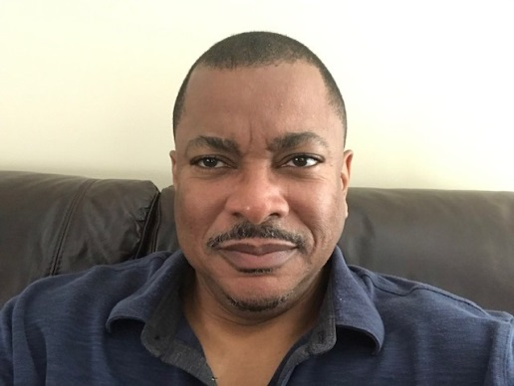
Derrick Fitzgerald is from Atlanta, Georgia. He attended the University of Georgia (Bulldog Nation) and finished his BBA in Finance at Georgia State University. He is the Premium Audit Division (PAD) Regional Manager of the East Region with American International Group, AIG, where he’s worked for 29 years. Derrick and his family relocated to Waxhaw, N.C. in 2008 from Woodbridge, N.J.
He’s is married to his lovely wife, Troyce, and they have a son, Devin, that enrolled at John Crosland in 2018. He also serves as a member of Los Bravos, Inc. which is a local non-profit organization that provides community assistance and he attends Transformation Church in Indian Land, S.C. He also loves to travel, sports, history, and fashions himself as a budding BBQ Pitmaster.

